Name : Dhivya Saravanan

RollNumber : 731621121015

E-mail : [dhivyavbm@gmail.com](mailto:dhivyavbm@gmail.com)

JAVA – PRACTICE

1) Fibonacci Series in Java

**Program :**

**package** google;

**public** **class** FibonacciSeries {

**public** **static** **void** main(String args[])

{

**int** n1=0,n2=1,n3,i,count=10;

System.***out***.print(n1+" "+n2);

**for**(i=2;i<count;i++)

{

n3=n1+n2;

System.***out***.print(" "+n3);

n1=n2;

n2=n3;

}

}

}

**Output :**

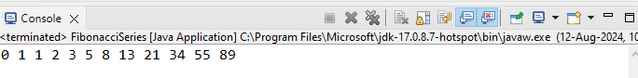

2) Prime Number Program in Java

**Program :**

**package** google;

**import** java.util.Scanner;

**public** **class** PrimeNumber {

**public** **static** **void** main (String args[]) {

Scanner sc = **new** Scanner(System.***in***);

**int** num = sc.nextInt();

**int** count = 0,i;

**for**(i =2;i<=num/2;i++){

**if**(num % i ==0 ){

count++;

}

}

**if**(count == 0){

System.***out***.print(num +" is a Prime Number");

}

**else**{

System.***out***.print(num +" is not a Prime Number");

}

}

}

**Output :**

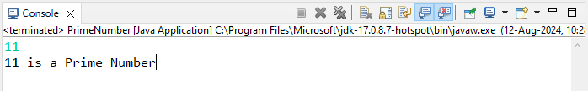

3) Palindrome Program in Java

**Program :**

**package** google;

**import** java.util.Scanner;

**public** **class** Palindrome {

**public** **static** **void** main (String args[]) {

Scanner sc = **new** Scanner(System.***in***);

**int** num = sc.nextInt();

**int** reverse = 0, rem, temp;

temp = num;

**while** (temp != 0)

{

rem = temp % 10;

reverse = reverse * 10 + rem;

temp /= 10;

};

**if** (num == reverse)

System.***out***.println (num + " is Palindrome");

**else**

System.***out***.println (num + " is not Palindrome");

}

}

**Output:**

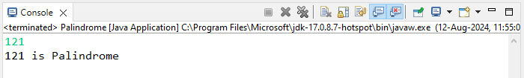

4) Factorial Program in Java

**Program :**

**package** google;

**import** java.util.Scanner;

**public** **class** Factorial {

**public** **static** **void** main(String args[]){

Scanner sc = **new** Scanner (System.***in***);

**int** number = sc.nextInt();

**int** i,fact=1;

**for**(i=1;i<=number;i++){

fact=fact*i;

}

System.***out***.println("Factorial of "+number+" is: "+fact);

}

}

**Output :**

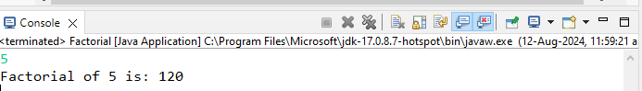

5) Armstrong Number in Java

**Program :**

**package** google;

**import** java.util.Scanner;

**public** **class** AmstrongNumber {

**public** **static** **void** main (String args[]) {

Scanner sc=**new** Scanner(System.***in***);

System.***out***.print("Enter a Number:");

**int** n=sc.nextInt();

**int** orginalnum,rem,res=0;

orginalnum=n;

**while**(orginalnum!=0)

{

rem=orginalnum%10;

res+=Math.*pow*(rem,3);

orginalnum/=10;

}

**if**(res==n)

System.***out***.println("Armstrong Number:"+n);

**else**

System.***out***.println("Not an Armstrong Number:"+n);

}

}

**Output :**

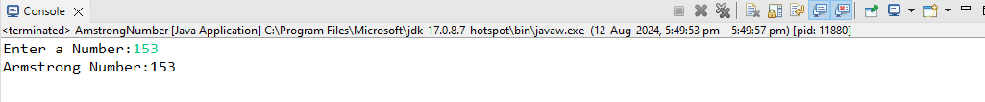

6) How to Generate Random Number in Java

**Program :**

**package** google;

**import** java.util.*;

**public** **class** RandomNumber {

**public** **static** **void** main(String args[]){

Scanner s=**new** Scanner(System.***in***);

**int** n=s.nextInt();

System.***out***.println(Math.*random*());

}

}

**Output :**



7) How to Print Pattern in Java

**Program :**

**package** google;

**import** java.util.Scanner;

**public** **class** Pattern {

**public** **static** **void** main(String[] args) {

Scanner sc= **new** Scanner (System.***in***);

System.***out***.println("Enter the value:");

**int** n= sc.nextInt();

**int** i,j;

**for**(i=0;i<=n;i++) {

**for**(j=1;j<=i;j++) {

System.***out***.print ("* ");

}

System.***out***.println (" ");

}

}

}

**Output :**

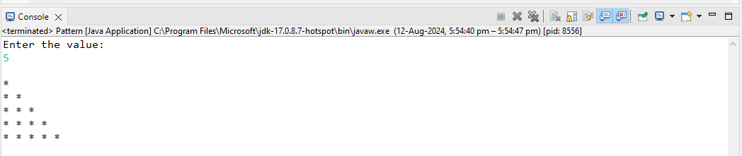

8) How to Compare Two Objects in Java

**Program :**

**Package** google;

**Import** java.util.Scanner;

**Public** **class** CompareObjects {

**Public** **static** **void** main (String [] args) {

Scanner sc = **new** Scanner (System.***in***);

System.***out***.print ("Enter the first string :");

String str1= sc.nextLine ();

System.***out***.print ("Enter the second string :");

String str2= sc.nextLine ();

**if** (str1.equals(str2)){

System.***out***.println ("same object");

}

**else** {

System.***out***.println("different object");

}

}

}

**Output :**

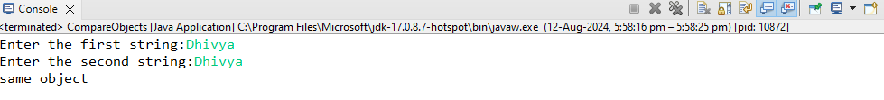

9) How to Create Object in Java

**Program :**

**Output :**

10) How to Print ASCII Value in Java

**Program :**

**package** google;

**public** **class** ASCII {

**public** **static** **void** main (String [] args){

**int** char1 = 'A';

**int** char2 = 'B';

System.***out***.println("ASCII value of a is : " +char1);

System.***out***.println("ASCII value of b is : " +char2);

}

}

**Output : **